Lab 4: Polymers and Nylon

Bijan Varjavand

Polymers are made of repeating structures of individual molecules. Each unit, known as a monomer, has unique interactions and grows into a polymer with 2 main methods, step growth and chain growth. Step growth utilizes monomers with multiple functional groups that react together, while chain growth utilizes unsaturated monomers to grow. Step growth forms multiple groups of higher molecular weight polymers, while chain growth involves “addition reactions” that consecutively add monomers to a growing chain. Interactions between polymer chains is known as crosslinking; notably hydrogen bonding which forms a strong ordered structure.

Nylon is a thermoplastic, actually one of the first successful synthetic thermoplastic polymer. It was intended to and was successful in replacing silk in a number of applications, such as in military parachutes and flak vests. Microscopically, Nylon has repeating amino functional groups, and is a type of polyamide. This means that the hydrogens on the carboxylic acid and amino groups are prime for hydrogen bonding, allowing for a strong and ordered polymer. The different functional groups that can be added to the nylon copolymer, as well as their positions, change the physical properties of the polymer drastically as seen in this lab.

The silly putty we made had very different properties based on the amount of crosslinker used (Borax into a glue and water solution). The analysis for these different types of putty were only qualitatively observed. The rheology of the 3 types are as follows: the less crosslinked was sticky and not firm, the medium was solid and more firm, and the most crosslinked exhibited the most solid form (this makes sense due to the impact of crosslinking on the properties). An interesting note is that the polymers had different strengths depending on strain rate. This is because of the entropic effects of the polymer chains sliding past each other.

For our lab we first synthesized nylon 6,10. A solution with 0.6g HDMA in 20mL water was added to a solution of 0.6 sebacoyl chloride and 20mL hexane. A film formed between the solutions, the nylon 6,10, which was then drawn out with a glass rod. For nylon 6, a solution was made by heating a solution of 5g Caprolactam, 0.1g POE (polyoxyethylene), and 3 drops of N-acetylcaprolactam. One the mass stopped bubbling and started to simmer, NaH was added and fibers were pulled from the molten polymer. Then we made different silly putty with different amounts of crosslinker.

We made nylon 6,10 and qualitatively observed the properties. It was very squishy at first because of the water. The next week it had shriveled up and had a spongey consistency. It fell apart easily with only a light tug. These physical properties can be explained by looking at the chemical components of the material **(Fig1, 2)**. Compared to Nylon 6,10, Nylon 6 had much stronger physical properties. This is due not only to the higher density of functional groups and associated crosslinking, but also the tenability of strength inverse to NaH. Initially a clear liquid solution like Nylon 6, after being heated then drawn out, became a clear yellow color. The greater mechanical properties also allowed the strand being drawn to hold itself together, resulting in very long strands as opposed to the Nylon 6 clumps. We can actually control the properties of out Nylon 6,10 polymer by changing amount of NaH. The figures below show the specific young’s modulus and tensile strength of different thicknesses of Nylon 6 **(Fig 3, 4)**. The 788 micron data collected shows a young’s modulus of 23.43 MPa and a UTS of 8.48 MPa. The 154 micron data collected shows a young’s modulus of 94.2 MPa and a UTS of 45.94 MPa. The literature values for nylon 6 are 2-4 GPa and 45-90 MPa for UTS and young’s modulus respectively. Our values deviated from these literature values significantly, by 97 and 32% respectively. The difference in values between nylon 6 and 6,10 can be explained by density of bonding by functional groups mentioned earlier, and deviation from literature values can be attributed to systematic errors, as well as random errors during preparation (such as slight mass deviation). Comparing our data to a fishing line **(Fig 5)**, which is likely made of a stronger form of nylon with enhanced crosslinking, we can see that it has far greater mechanical properties than the literature values.

**Figures:**

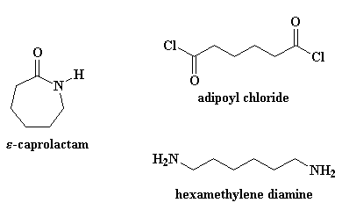

-----------------------------------------------------------------------------------------------

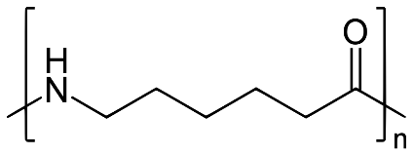

Figure 1: Nylon 6 reactants (above) and Nylon 6 product (below)

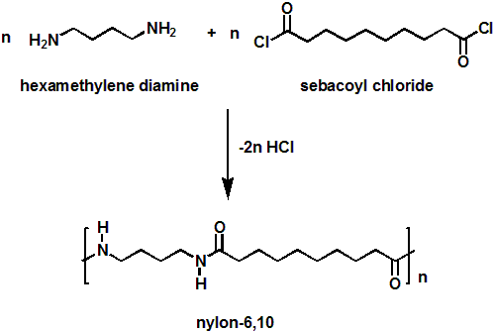

Figure 2: Nylon 6,10 reactants and products

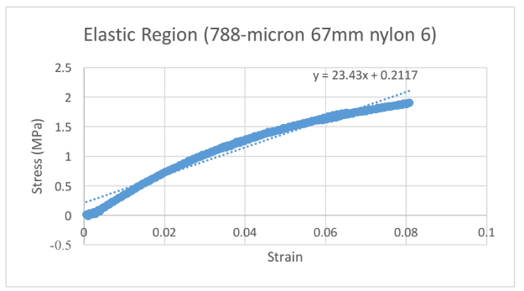

Figure 3: 788 microns, Gauge length 67mm, tensile test sample

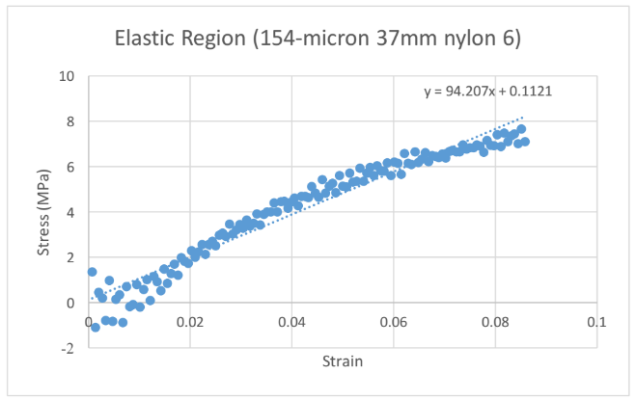

Figure 4: 154 microns, Gauge length 37mm, tensile test sample

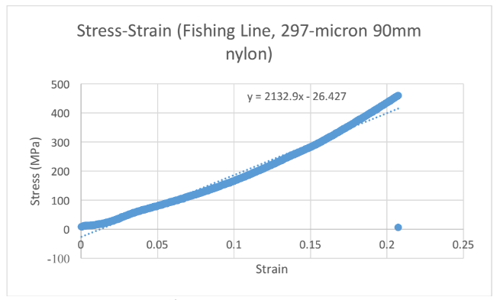

Figure 5: Fishing line data